**S.2 BEGINNING OF TERM 3 EXAMS 2022**

**ICT**

**TIME: 1 HR**

INSTRUCTIONS:

ANSWER ALL QUESTIONS

1. A number of learners have lost books in fires that have been gutting schools in Uganda over years. This causes a setback in the learners’ performance. The time they would have spent revising their books they spend it copying lost notes. With the use of ICT this can be avoided.

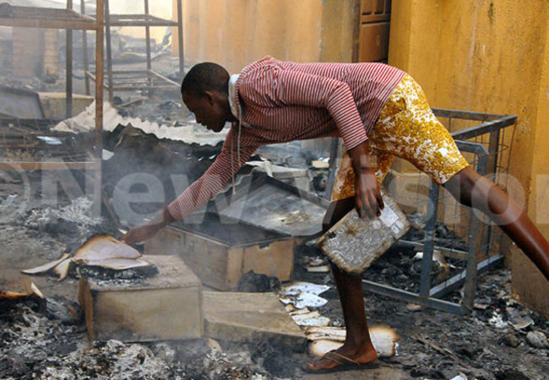

Task:

In an essay, how can the schools safely use ICTs to help learners recover the learning materials quickly?

1. ICTs are currently being employed in almost all fields in this modern era. Some of these fields are Education, Banking and Security. In the area of education, it is possible for a teacher in London to virtually conduct a lesson in a school in Uganda.

***Tasks***

1. Explain how the lesson above can be conducted with ICTs.

1. Explain the precautions that should be exercised when using the ICT tools in (a) above.

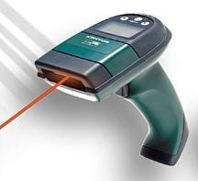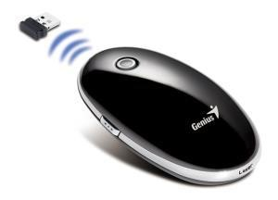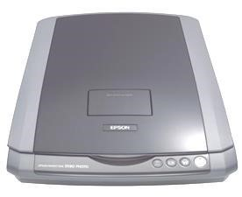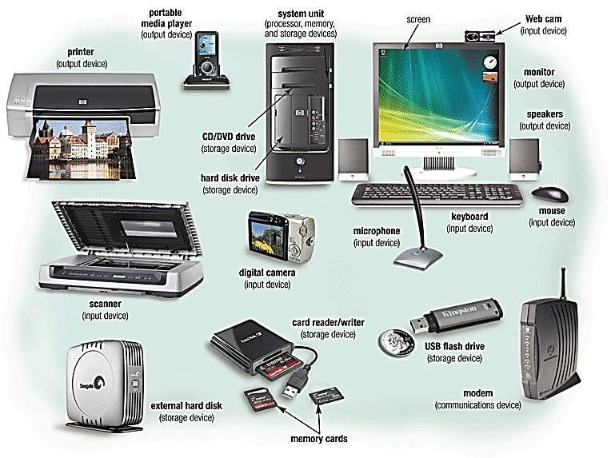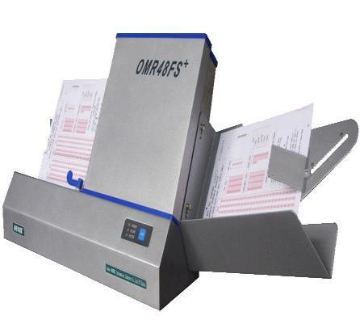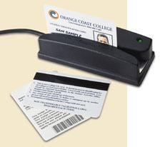

**3.A**

**P**

**H**

**O**

**T**

**O**

**M**

**O**

**N**

**T**

**A**

**G**

**E**

**O**

**F**

**T**

**H**

**E**

**CO**

**MM**

**O**

**N**

**H**

**A**

**R**

**D**

**W**

**A**

**R**

**E**

**D**

**E**

**V**

**I**

**C**

**E**

**S**

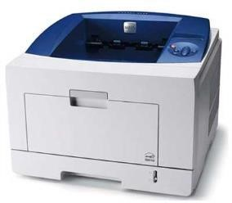

Identify five devices and explain how they work